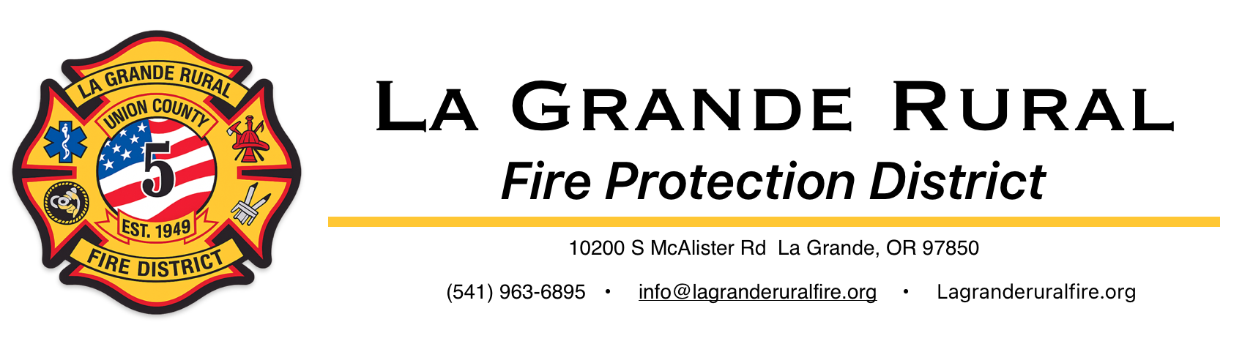

The Fire Line
June 2026 Our first edition!


Here’s what we’ve been up to
Welcome to our inaugural edition of The Fire Line, La Grande Rural Fire District (AKA Island City Fire Dept)’s periodic newsletter! We hope you will find this informative and helpful. If you have any questions, please reach out to us at info@lagranderuralfire.org.

About us:
LGRFPD was founded in 1949 to provide fire protection services to the area surrounding La Grande, Oregon, including Island City. We now provide comprehensive fire suppression, prevention and education, rescue and emergency medical services to an area of 135 square miles and around 6,000 residents. Our Fire District is almost entirely volunteer-based.
We are:
“Neighbors helping neighbors”

Member Spotlight:
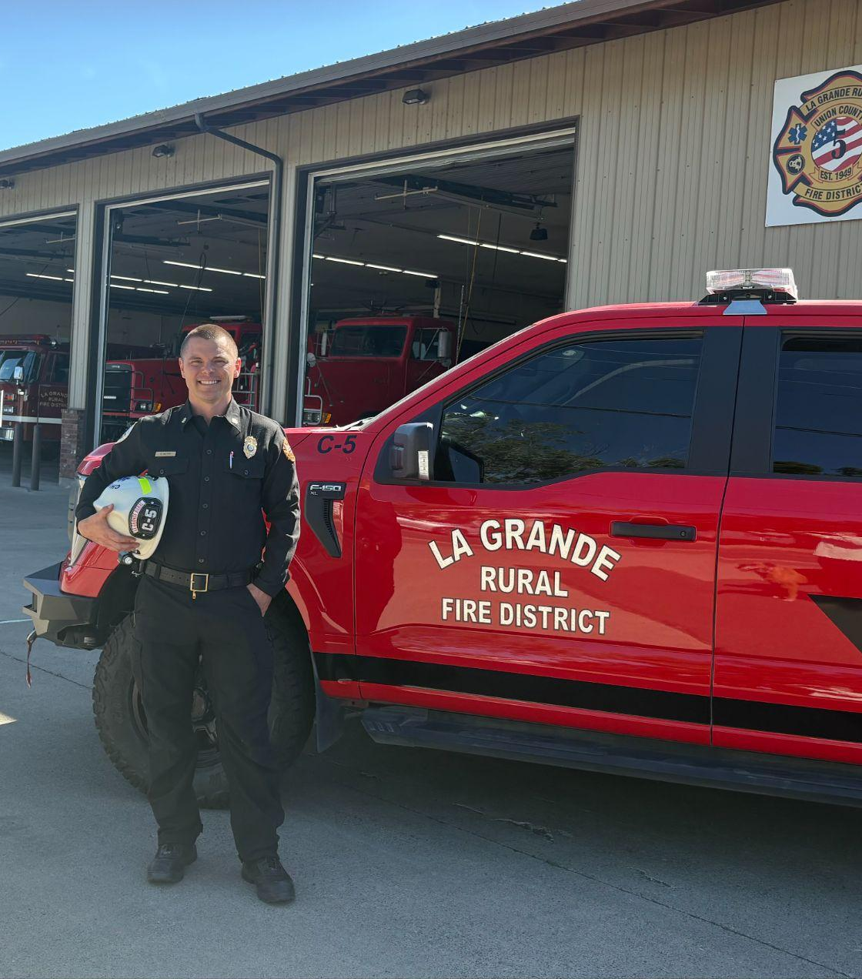

This month’s member spotlight is our new Fire Chief, Brady Walters!

Following a nationwide recruitment effort, Brady Walters has been selected as the new chief of La Grande Rural Fire Protection District.
Originally from Medford, Chief Walters began his emergency services career in 2005 as an Explorer and EMT with Mercy Flights Ambulance and as a volunteer ski patroller and firefighter in Southern Oregon. He graduated from the paramedic program at Chemeketa Community College while working as a student firefighter for Marion County. A significant part of his early career was 12 years working for the National Park Service in law enforcement and emergency services. Brady was stationed in parks across the country, including the Grand Canyon, Hawaii, and finally Crater Lake here in Oregon.
Over his career with the NPS, Walters served as Emergency Medical Services Coordinator, Volunteer Ski Patrol Director, a Law Enforcement & Emergency Services Instructor, Fire Engineer, Search & Rescue Technician, Acting Operations Supervisor, and Field Training Coach.
Brady left the NPS in 2020 and began working for the Yamhill County Sheriff’s Office. As a Patrol Deputy, he developed and implemented a dual-role Paramedic-Deputy program, allowing him to carry rescue gear and provide first response to critical medical emergencies or tactical situations. Additionally, Brady served as a Search & Rescue Coordinator and Cadet Program Advisor. During this time he wanted to keep his fire skills sharp, so he joined Polk County Fire District #1 as a volunteer, rapidly making his way up the ranks to Engineer, Lieutenant, and Captain.

Brady decided to make a career change out of law enforcement and pursue a leadership role in the fire service, as the Deputy Chief and Training Officer for Hoskins-Kings Valley Fire District. At HKV, Chief Walters made significant improvements to operations and the training program leading to increased volunteer involvement, safety and efficiency.
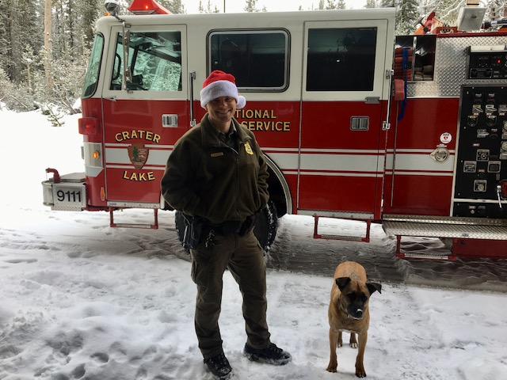
Brady, his wife Jena, and their two dogs are excited to move to La Grande and begin a new chapter. They both look forward to getting to know the community, developing friendships, and exploring the beautiful surroundings.
Brady has a passion for volunteerism and is committed to an inclusive and supportive culture within the department. Brady’s goals as Fire Chief include:
- A mission-driven mindset
- Safety and accountability to our community
- Fiscally responsible and transparent management
Chief Walters is very grateful for this opportunity and for the support of the many people who have made this transition possible. He would love to meet with community members to discuss any ideas or concerns you may have.

Recent Calls:
🚚🔥 On May 21, LGRFPD responded to an oil truck on fire near Island Market. Fortunately, an OSP Trooper was nearby and along with the driver was able to contain the fire to the engine compartment with fire extinguishers.
⚠️ On May 27, LGRFPD was called to a natural gas leak at a local restaurant. The building was evacuated and the situation handed off to utility personnel.

🚨 On June 4 LGRFPD, City of La Grande Fire District, ODOT and law enforcement partners responded to a serious injury rollover crash on Hwy 30. The patient was transported to GRH.
🔥On June 8, LGRFPD, ODF and City of La Grande Fire Dept responded to two simultaneous wildland fires near the railroad tracks near Perry and Hilgard. The fires were controlled.
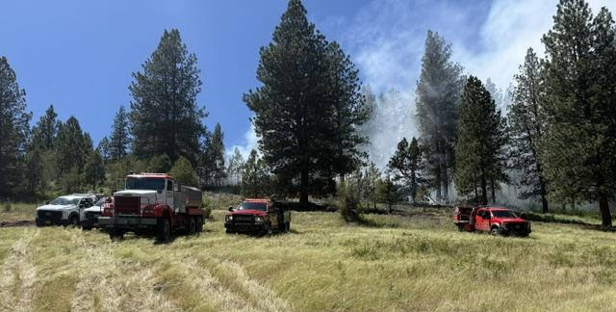
🔥On June 12, LGRFPD assisted Elgin Fire, ODF and USFS with an approximately 2 acre wildland fire off Shaw Creek Rd. The fire was eventually extinguished with work continuing into the next day.
🚨 On June 13, LGRFPD, La Grande City Fire Dept and law enforcement partners responded to I-84 near Ladd Canyon Summit for a rollover motor vehicle crash. The patient was deceased upon arrival.
🔥On June 14, LGRFPD provided automatic aid for a trailer home fire in North Powder. All occupants were evacuated and the fire was controlled.
🔥On June 16, LGRFPD, ODF and many other county fire resources were dispatched to a rapidly growing field fire off Hot Lake Ln. The fire was quickly contained before it could spread further. Preliminary investigation indicated a farming implement struck a rock causing a spark.
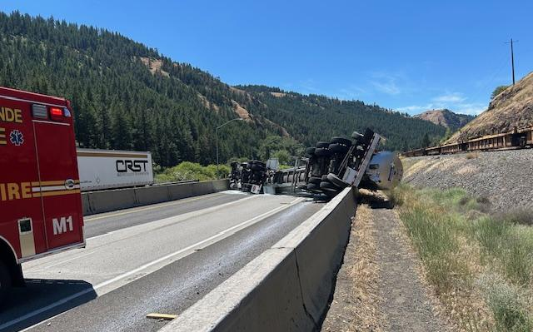
🚨 On June 24, LGRFPD and other emergency services responded to a tanker truck rollover on I-84 just west of La Grande blocking the entire westbound lanes. The truck was thankfully only carrying milk and the driver was uninjured. I-84 remained closed for several hours during clean-up.
🔥 Also on June 24, LGRFPD, LGFD, ODF and other agencies responded to a two-alarm wildland fire off McAlister Rd. The fire was contained before spreading further. Initial cause determined to be from metal work.
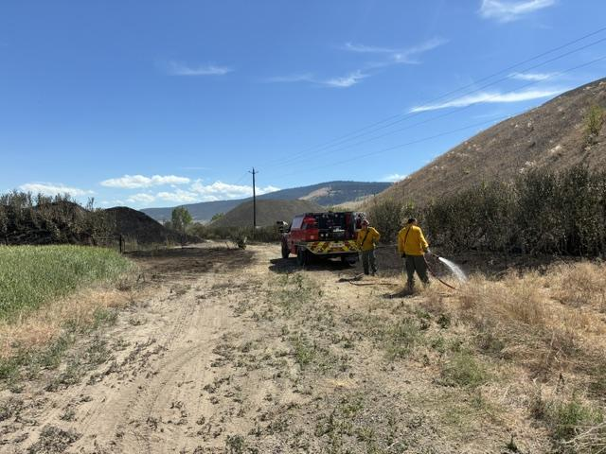
🔥 June 25 we responded with our partners to a wildland fire off Evergreen Dr. The fire was contained quickly before spreading into deeper vegetation.

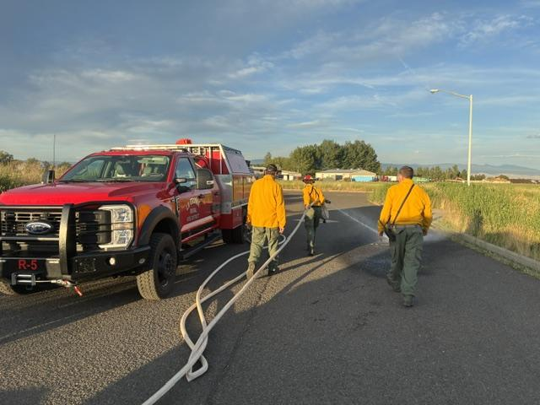
Recent Training & Events:
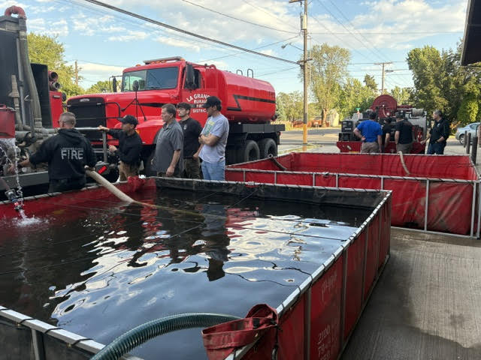
🚒 Our crews have been preparing for fire season with with wildland-specific training such as mobile attack with tenders and brush trucks and pre-incident planning.
⛑️ Crews attended heat emergencies and drowning training at EMS drill night with La Grande Fire Dept.

🛩️ Chief Walters attended an aviation emergencies training and Lifeflight orientation, along with the Eastern Oregon Search & Rescue Conference.
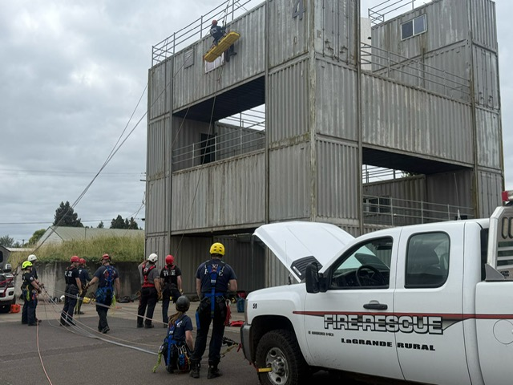
🧗Firefighter Akers attended Rope Rescue Training at the Oregon Volunteer Firefighters Association Conference in Brooks.
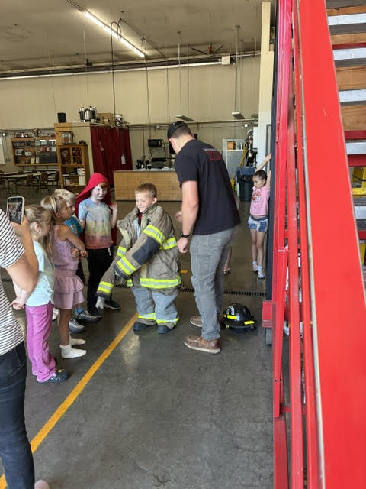
🏫 On May 21 we hosted 3rd graders from Island City Elementary for a fire station tour, we had as much fun as they did!

Projects:

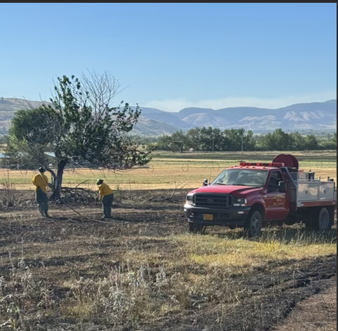
We are very grateful to have been awarded the Wildfire Season Staffing Grant from the Oregon State Fire Marshal’s Office for another year.
This grant allows us to pay our members to staff the fire station during peak hours, reducing response time and therefore damage and risk from fires to our community.
In addition to call response, personnel use this time to train, maintain equipment and the station, and patrol our area.

Our volunteers assisted the City of La Grande Fire Dept along with other allied healthcare professionals with another year of Medquest.
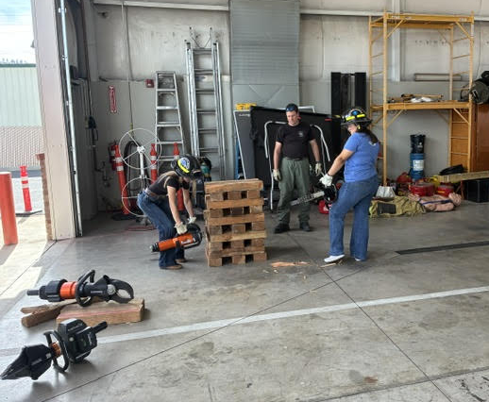
MedQuest is a foot in the door to healthcare. At this AWARD-WINNING summer camp for Oregon high schoolers, students shadow health professionals, learn real-life skills, and get connected with resources that can help them make the next step in their career—all while meeting others from around the state who are excited about healthcare too. For more info see: https://www.neoahec.org/pathway-programs/medquest/

Future projects around the Fire Station:
Our staff have been working away on operational improvement and safety projects. Some examples include:
- Upgrading scene and emergency lighting on our vehicles.
- Establishing work groups to focus on safety needs, apparatus projects and upgrades, our training program, and strategic planning for the future.
- Focusing on member health and wellness with physical fitness and mental health awareness and support.
- Improving our capability for emergency medical and rescue response.

LGRFPD seeking volunteers for Fire Support and Auxiliary Program:
La Grande Rural Fire District is seeking dedicated community members to join our Auxiliary and Support Group. If you want to serve your community behind the scenes, we have a critical role for you!

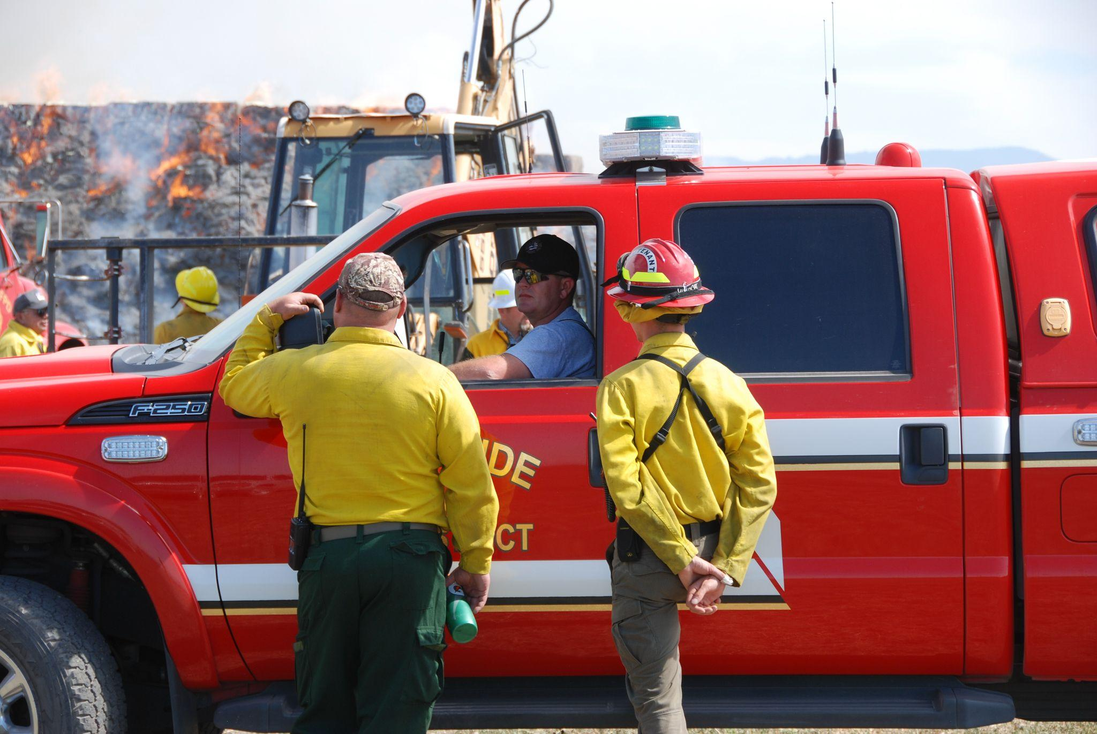
HOW YOU CAN HELP
- Be available to assist with fires and other emergency situations.
- Incident Support & Rehab: Assisting firefighters with hydration and rest.
- Traffic Control: Managing safety at incident locations.
- Driver Only: Operating support vehicles.
- EMS Only: Assisting with medical calls.

- Administrative & Facilities: Station maintenance, administrative support and public outreach/education.

WE NEED YOU
We are looking for volunteers who are 16+, possess a valid driver's license, can pass a background check, and are committed to attending training and events.

WHAT CAN YOU EXPECT?
- Contribute to something bigger.
- Help your neighbors.
- Learn valuable first aid and emergency skills.
Ready to get started?
Fill out our volunteer interest form or call 541-963-6895
- Be a part of an awesome group of people.

- Training and experience.

Prevention corner:

Burn Ban in effect
The Union County Board of Commissioners approved the Fire Defense Board’s request for early entry into regulated fire season on June 3. The ban which will remain in effect through Sept. 30 unless extended.
Open burning is prohibited during fire season with the exception of regulated agricultural field burning and authorized prescribed fires.
Burning is prohibited on windy days. The county’s burn ordinance outlines the regulations:
• Burn barrels are allowed from 6-10 a.m., but must be located in a cleared area with a 10-foot radius free of flammable materials and at least 25 feet away from any structure
• Burn barrels must be fitted with a heavy metal screen
• Burn barrels must be attended at all times with both water and a shovel
• Recreational fires are permitted in approved fire rings, which must be less than six feet in diameter. Fires must be constantly attended until they are fully extinguished.
• The Oregon Department of Forestry permit requirements apply within ODF-protected areas

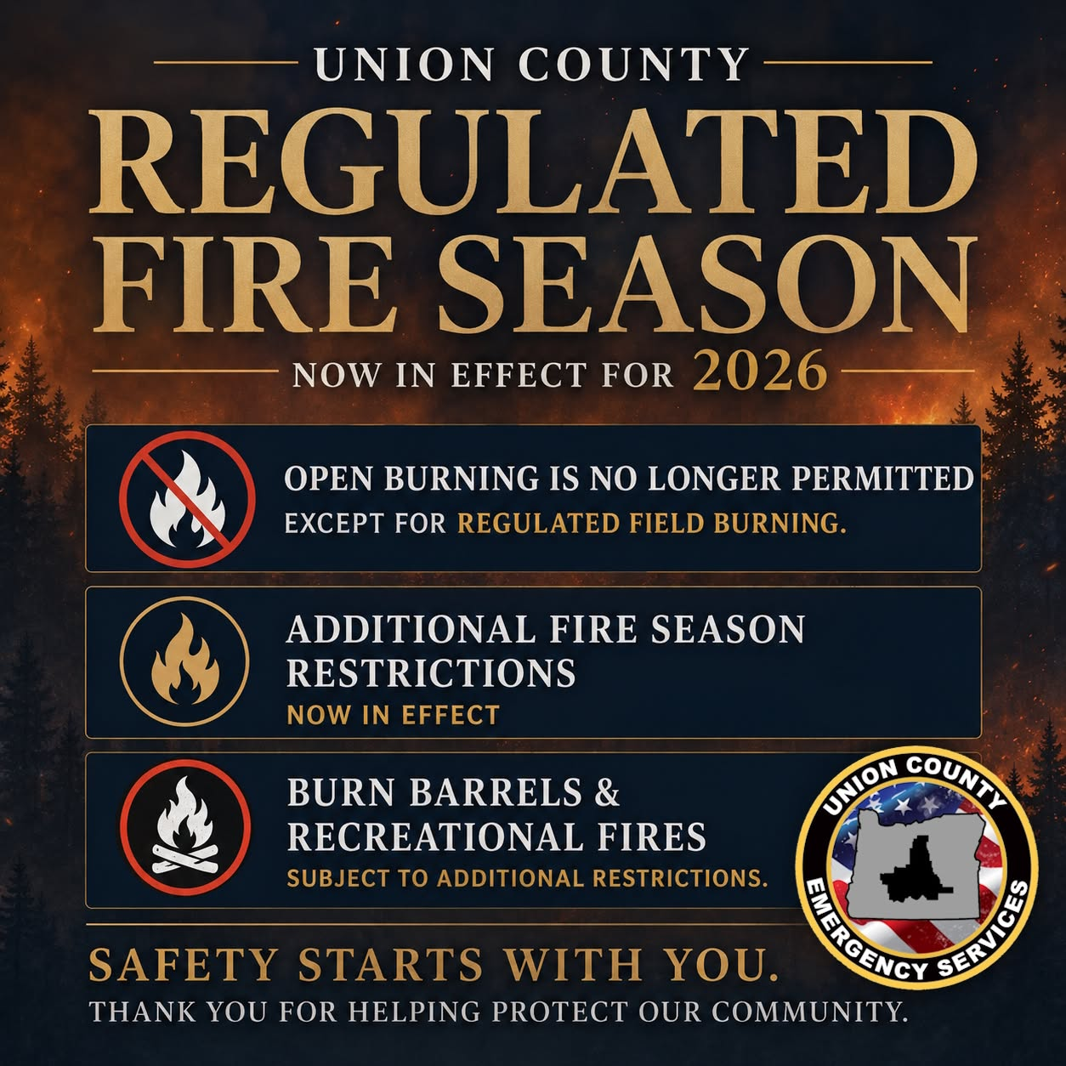

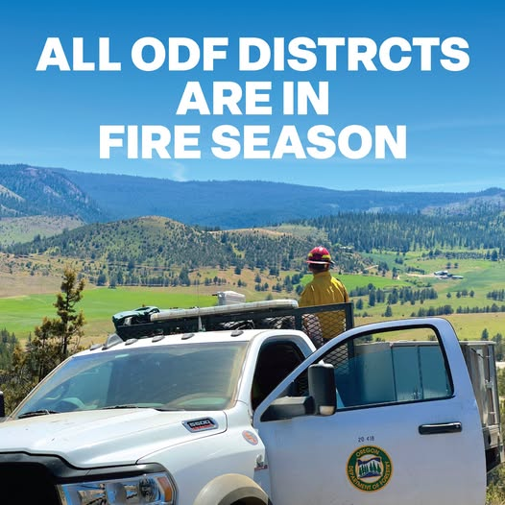
FIRE SEASON!
All Oregon Department of Forestry (ODF) districts are in fire season. This means that to reduce the risk of human-caused wildfires, fire restrictions may be in place where you live or at a destination you plan to visit or recreate.
For more information visit: https://www.oregon.gov/odf/fire/Pages/Restrictions.aspx

Independence Day Safety:

As we celebrate the 250 birthday of the United States, we ask our fans & followers to celebrate safely.
There are two times as many fires reported on Independence Day than on any other day. 50% of those are from fireworks.
-IAFF
Emergency Department visits in the United States between July 4th-5th jump approximately 21%, with increases in trauma and burns (fireworks accidents), food-related illness (maybe that potato salad wasn’t good), heat illness (is it just me or is it hot out here) and alcohol-related injuries (“hold my beer and watch this”).
On average, fireworks start 18,500 fires per year causing an average of three deaths, 40 civilian injuries, and an average of $43 million in direct property damage [NFPA].
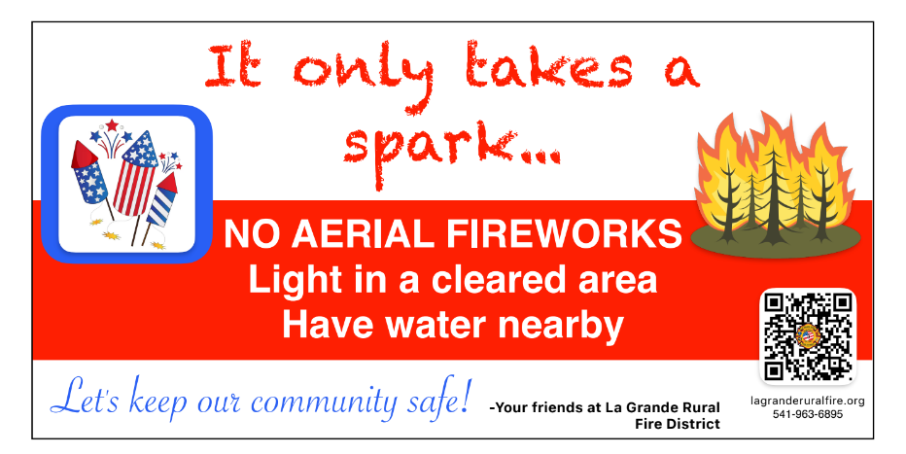


Lastly, please don’t drink and drive, and buckle up!!

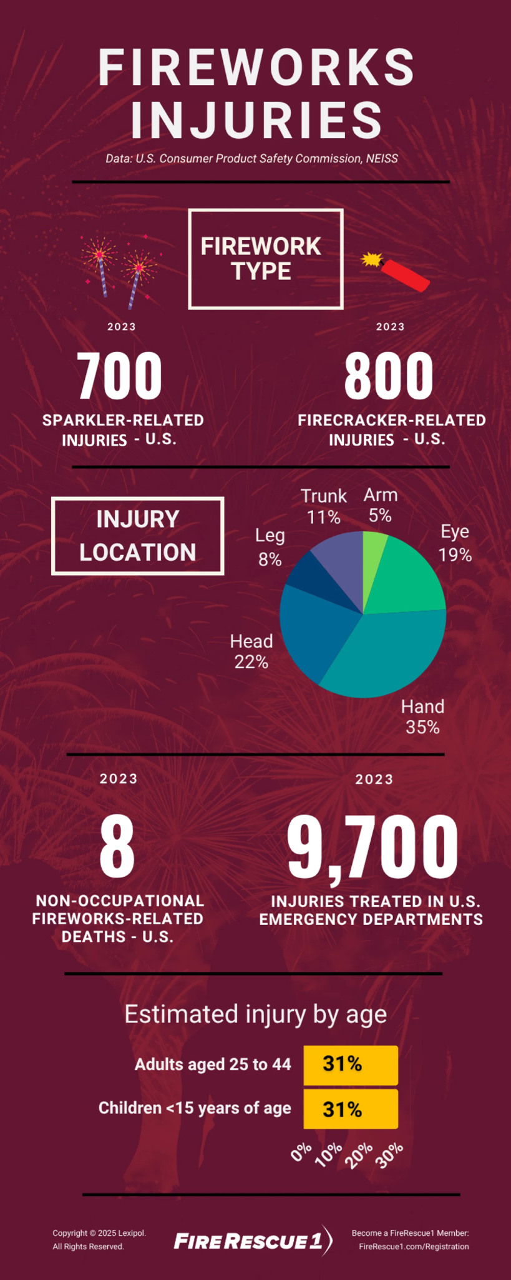

Board of Directors:
Our citizens elect a five-member Board of Directors to govern the Fire District. The Board meets on the second Tuesday of each month at the La Grande Rural (Island City) Fire Station at 6:00pm. The public is always welcome to join!
May and June meetings include our budget hearing. At these meetings the budget committee, which includes our Directors and members of the public review and vote on the proposed budget for fiscal year 2026-27.

Your Fire District Board of Directors:
Jake Hanson - President
Brett Rudd - VP
Will Burns
Tom Blackman
Kyle Hampton

Below is the approved budget from the June meeting:
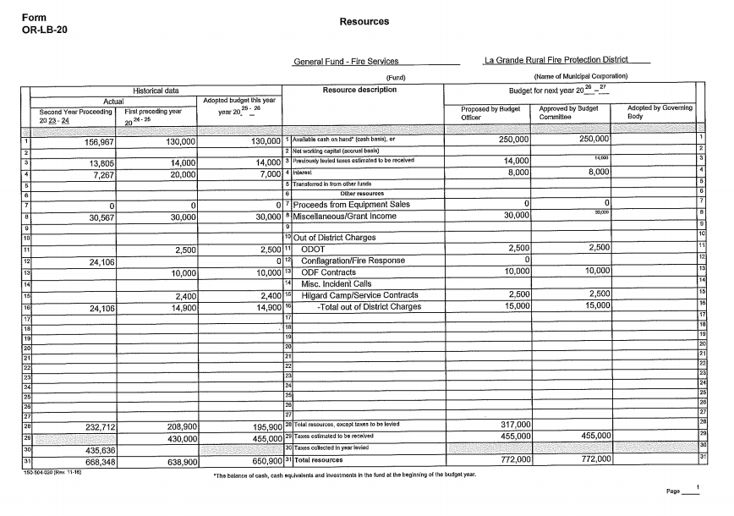

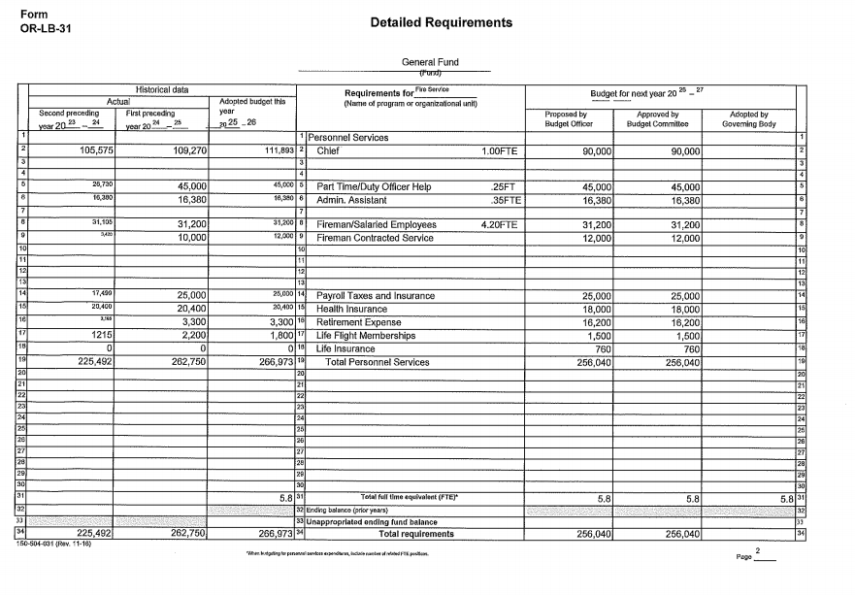
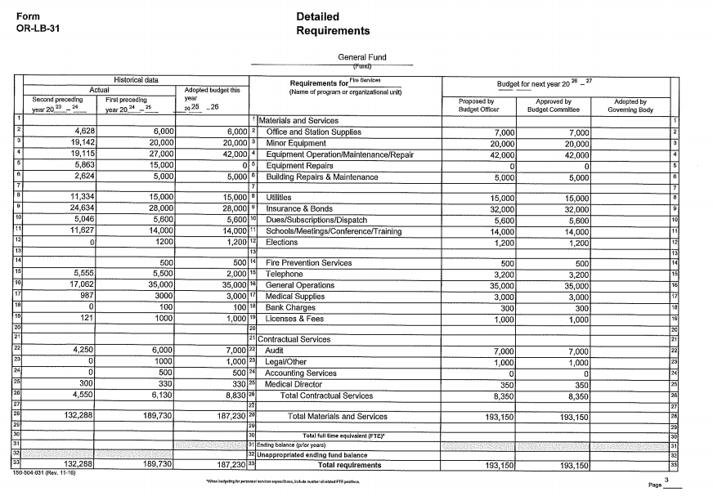

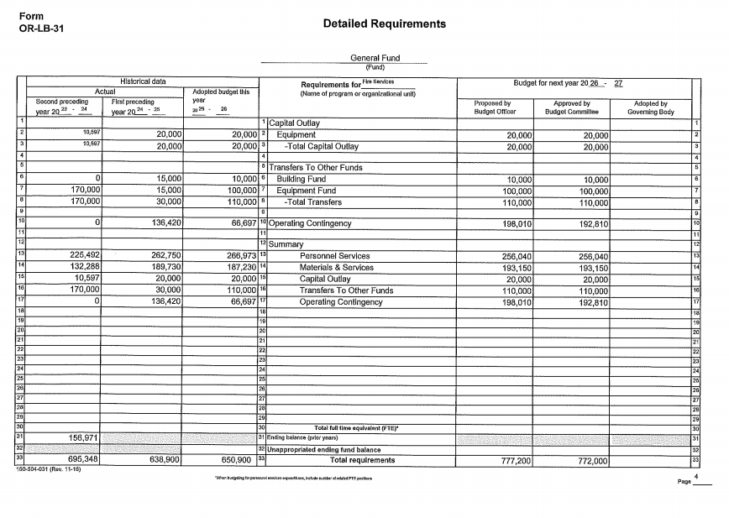
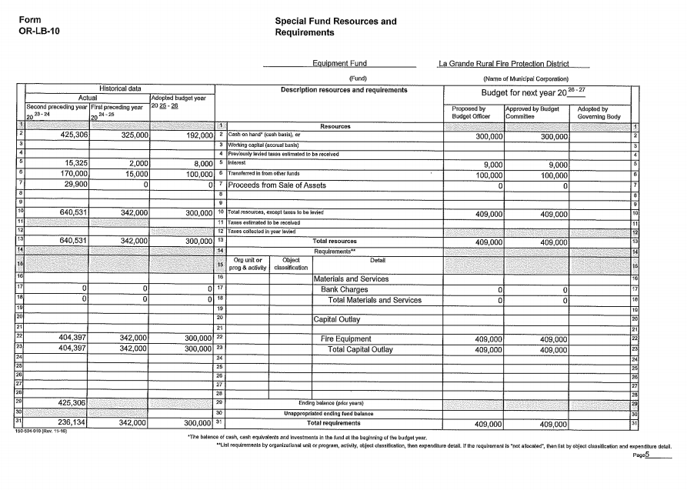

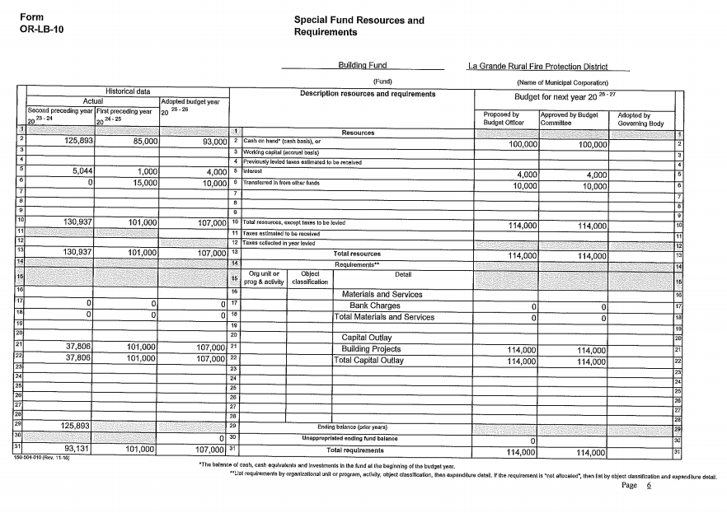
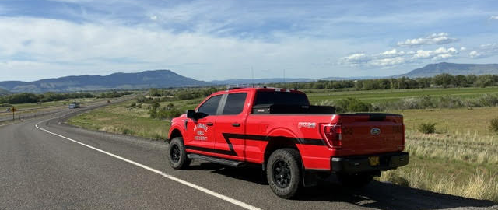
The Board can be reached at board@lagranderuralfire.org or by mail at 10200 S. McAlister Rd
La Grande, OR 97850


Questions, comments or concerns…reach out to us!
info@lagranderuralfire.org
541-963-6895
10200 S. McAlister Rd
La Grande, OR 97850

